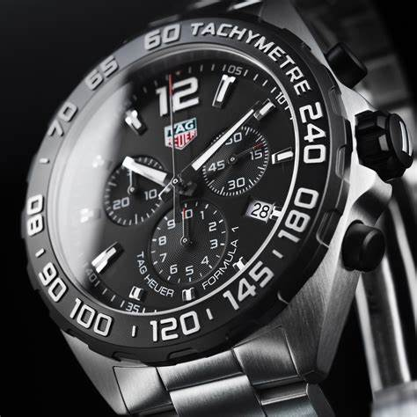Description: Tag Heuer is a renowned Swiss luxury watch brand known for its precision, innovation, and strong ties to motorsports. Founded in 1860, the brand has a rich history of creating high-performance timepieces, including chronographs and watches designed for racing and extreme sports. Tag Heuer is famous for its **sporty yet elegant designs**, blending technical features with sophisticated craftsmanship. Iconic models such as the **Carrera, Monaco**, and **Aquaracer** showcase advanced mechanisms like **automatic movements, chronograph functions**, and **water resistance**. With their focus on accuracy and style, Tag Heuer watches have become synonymous with high-end sports watches, appealing to both collectors and athletes who demand excellence in design and performance.